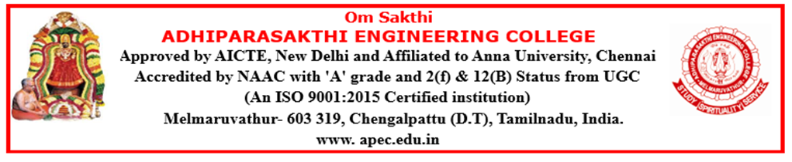

DEPARTMENT OF INFORMATION TECHNOLOGY
NEWS LETTER
The Times of Neural APEC
2026-2027

The Department of Information Technology is committed to fostering academic excellence by delivering quality education, promoting innovative learning, and providing industry-oriented training. During the academic year 2026–2027, the department successfully organized a wide range of technical events, value-added courses, workshops, seminars, guest lectures, industrial interactions, and hands-on training programs. These initiatives enhanced students' technical knowledge, practical skills, problem-solving abilities, and professional competencies, preparing them to meet the evolving demands of the IT industry and contribute effectively to society.
INDUSTRIAL VISIT
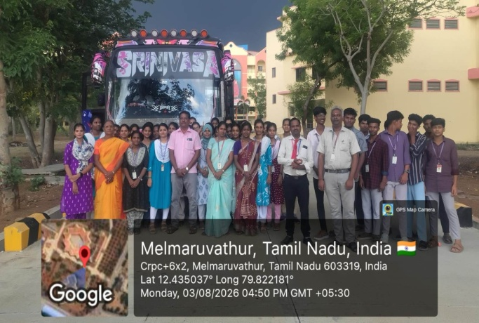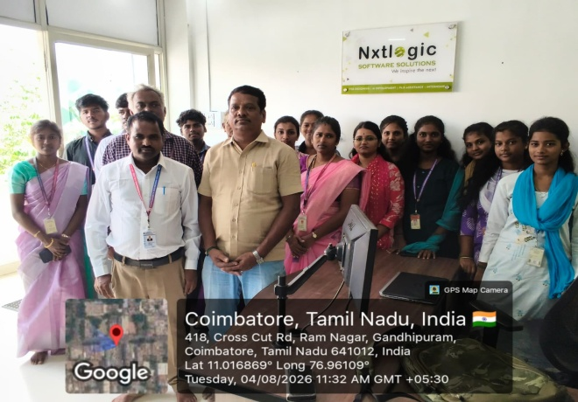
Industrial Visit to Coimbatore Nxtlogic Software Solutions,Tamil Nadu (III Yr)
The Department of Information Technology organized an Industrial Visit to Nxtlogic Software Solutions, Coimbatore, on 04 August 2026 to provide students with practical exposure to the Information Technology industry.
Nxtlogic Software Solutions is an IT and research-oriented company based in Coimbatore, Tamil Nadu. Established in 2009, the company provides various technology-oriented services including Web Design and Development, Artificial Intelligence, Mobile Application Development, E-Commerce Development, Cloud Solutions, Digital Marketing, Internship Training and Corporate Training.
During the visit, the students had an opportunity to gain an understanding of the functioning of an IT company and the role of different technologies in real-world applications. The visit provided valuable exposure to software development practices, emerging technologies, project-based learning and professional work culture.

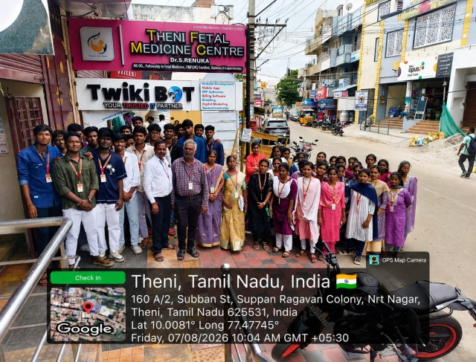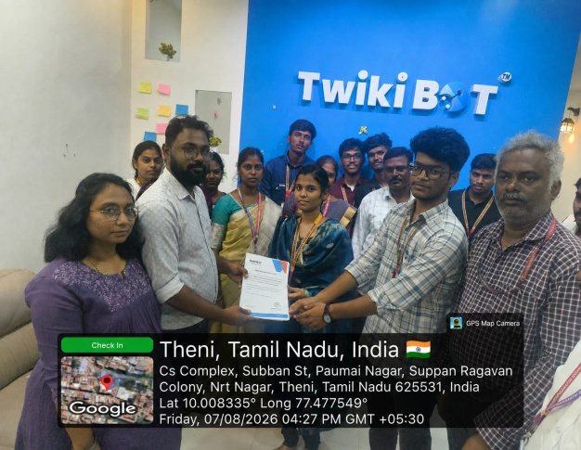
Industrial Visit to TwikiBot Technologies, Theni, Tamil Nadu (IV Yr)
The Department of Information Technology organized an Industrial Visit to TwikiBot Technologies, Theni, Tamil Nadu, on 07 August 2026 to provide students with practical exposure to the software industry and to enhance their understanding of real-world IT applications.
TwikiBot Technologies is a software development and digital marketing company based in Theni. The company provides a range of technology solutions including Web Development, Mobile Application Development, Custom Software Development, Digital Marketing, Branding, POS Solutions and Web Application Development.

DEPARTMENT ACTIVITIES
VALUE ADDED PROGRAM
Duration | Topic | Duration in Days | Details of Training Partner | Class
10/08/26 to 14/08/26 | Cyber Security | 10 DAYS |  | IV YEAR

PARENTS MEETING
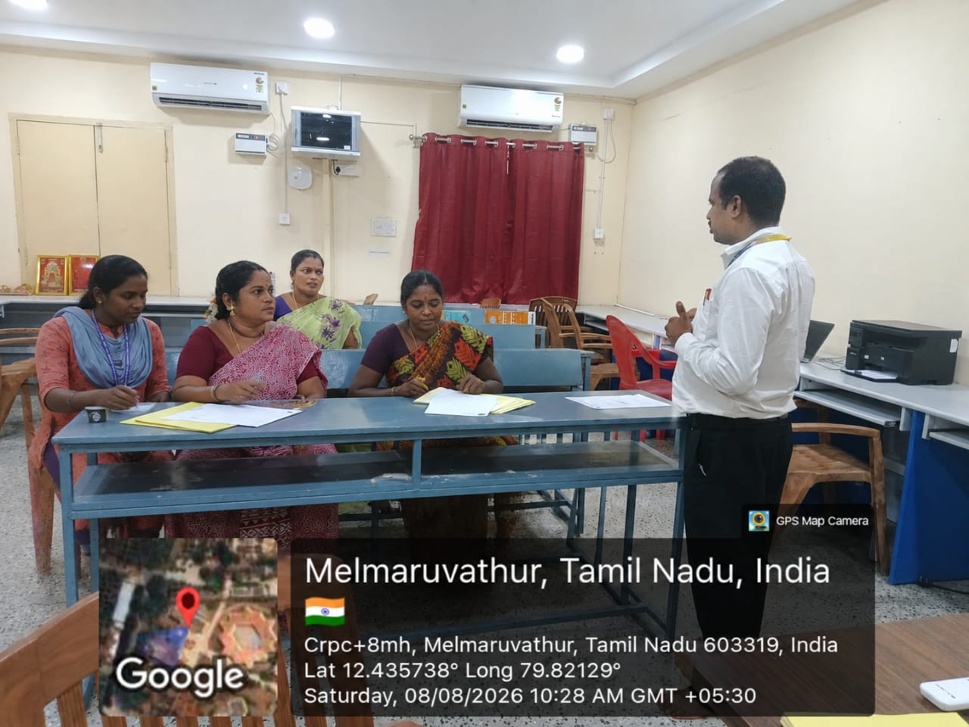
III- Year Parents Meeting on 08-08-26

GUEST LECTURE
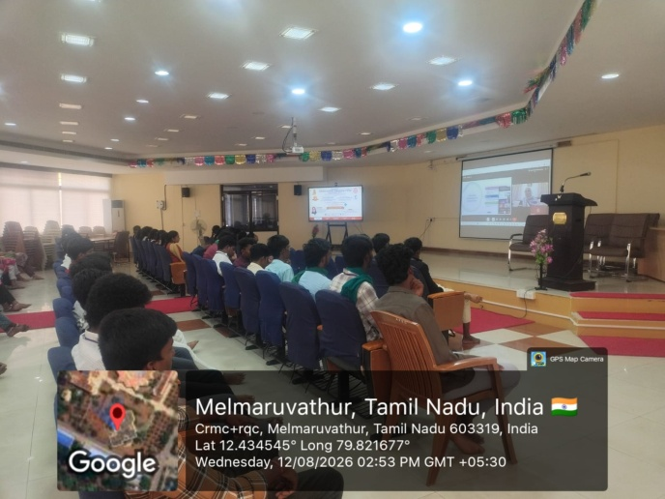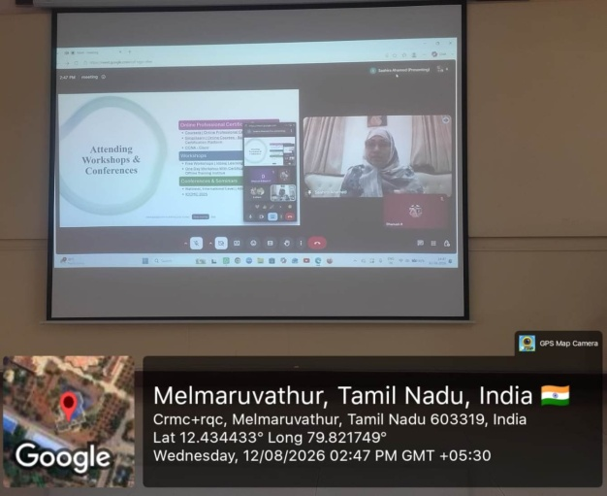

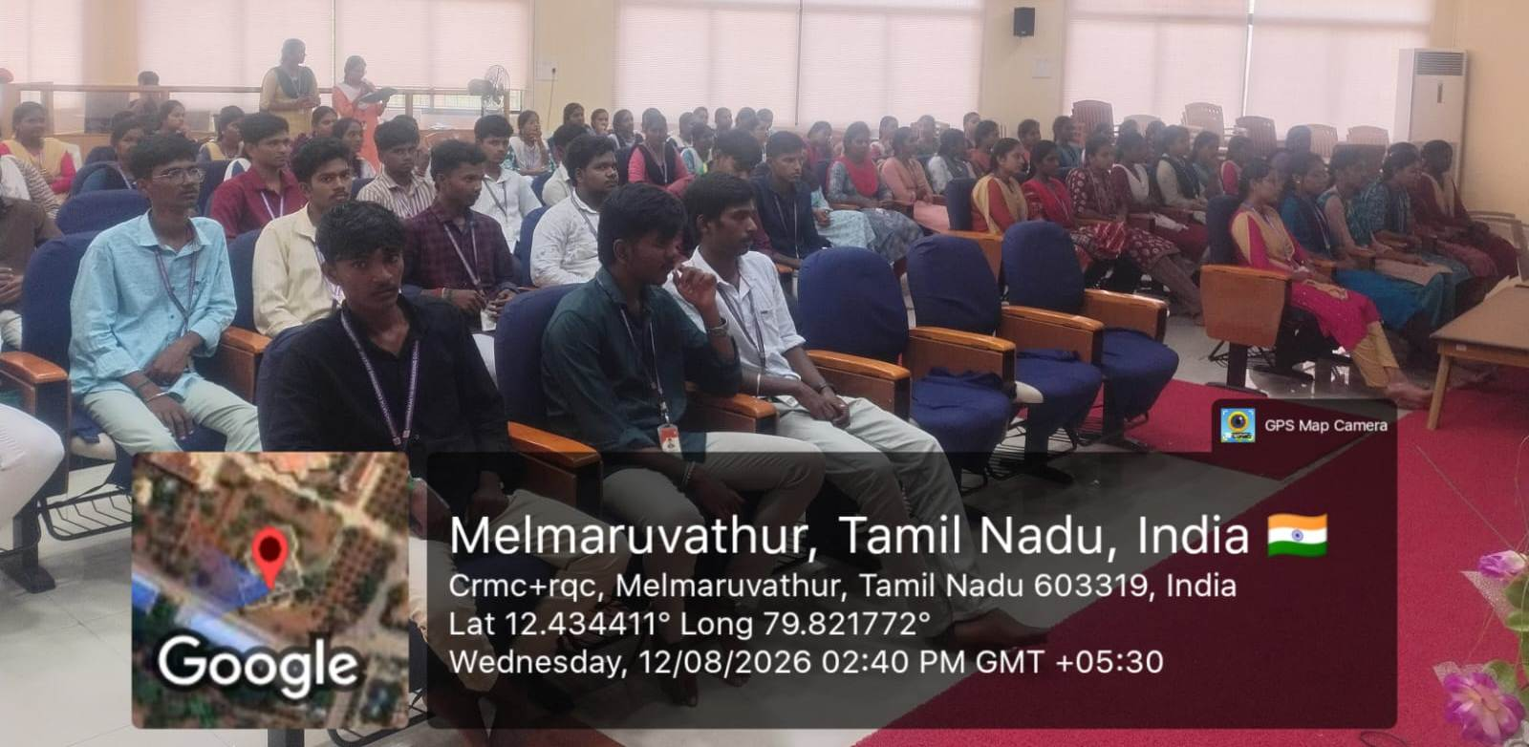
GUEST LECTURE ON “FROM CLASSROOM TO CAREER” APEC ACM Student Chapter on12-08-26
The Department of Information Technology, in association with the APEC ACM Student Chapter, organized a Guest Lecture on “From Classroom to Career: Building Your Future from the Graduation Project to Research and Foreign Job Opportunities” on 12 August 2026 (Wednesday) from 2:30 PM to 3:30 PM at the H Block Seminar Hall, Adhiparasakthi Engineering College, Melmaruvathur.
The session was delivered by Dr. A. Saahira Banu, MCA, M.Phil (CS), Ph.D. (CS), Assistant Professor, Department of Computer Science, College of Engineering and Computer Sciences, Mahailеh Campus for Girls, Jazan University, Kingdom of Saudi Arabia.
The guest lecture focused on helping students understand how their graduation projects can be transformed into valuable career and research opportunities. The resource person explained the importance of selecting innovative project topics, developing practical technical skills, documenting projects effectively, and identifying opportunities for higher studies and research.
The session also provided valuable guidance on research careers, foreign job opportunities, skill development, career planning and professional growth. Students gained useful insights into the expectations of higher education institutions and the global IT industry.
The interaction with the resource person encouraged students to think beyond classroom learning and prepare themselves for future academic and professional opportunities. The session was highly informative and served as a valuable platform for students to connect their academic knowledge with real-world career possibilities.

